Lucas Chan

Delan Elliot

Derek Hirotsu

Jim Ko

Daniel Park

COMP 1536 Milestone 3

Our site can be viewed at: <insert LINK>

## Items Completed for this Milestone:

* Base CSS created for site
  + Design implemented through flexbox
  + Forms designed
  + Tables designed
  + Layout finalized
* All pages created and written in HTML
  + Validated CSS, HTML, and Accessibility
* A/B testing of design elements

## Key Issues

We some difficulty creating a Stylesheet that would work for the multiple layouts we use on our site. It was somewhat difficult to try to reduce the number of classes we implemented in CSS. The balance of desired features and cross-compatibility was also difficult in the design phase.

## Deviations from initial design

We altered our design slightly to have a page wide banner, as after testing we felt we had a better response to the page-wide design. We changed the color palette slightly but maintained the theme for which we were aiming.

## Documentation:

Home Page:

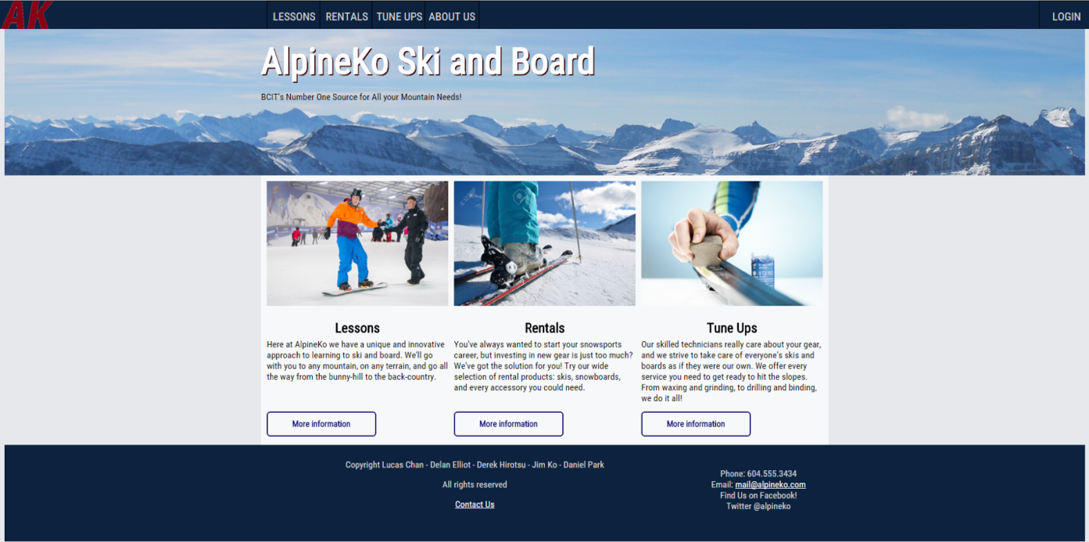

## A/B Testing:

**Home Page**

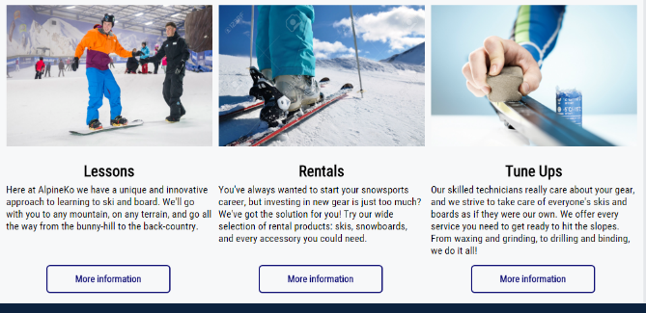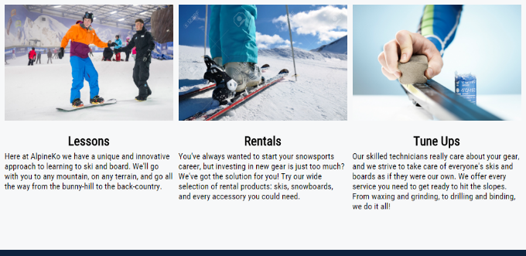

Tested for visual clarity of only clickable images versus buttons.

**Rentals Page**

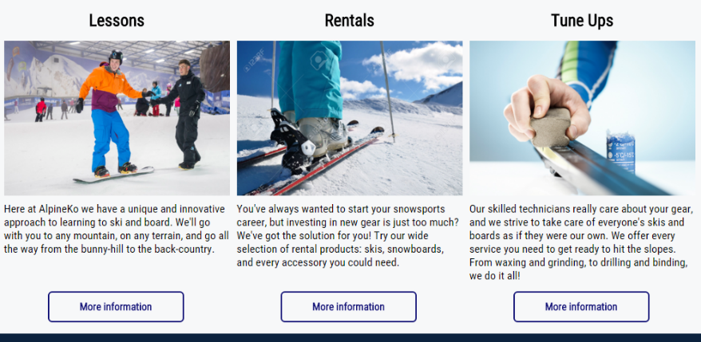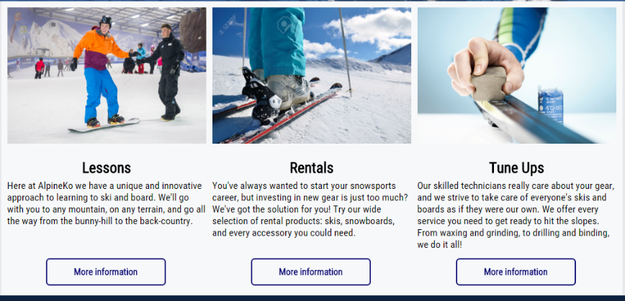

Tested for visual clarity in regards to having the headings above the images and separated from the body paragraphs versus having both the headings and the body together under the images.

**Lessons Page**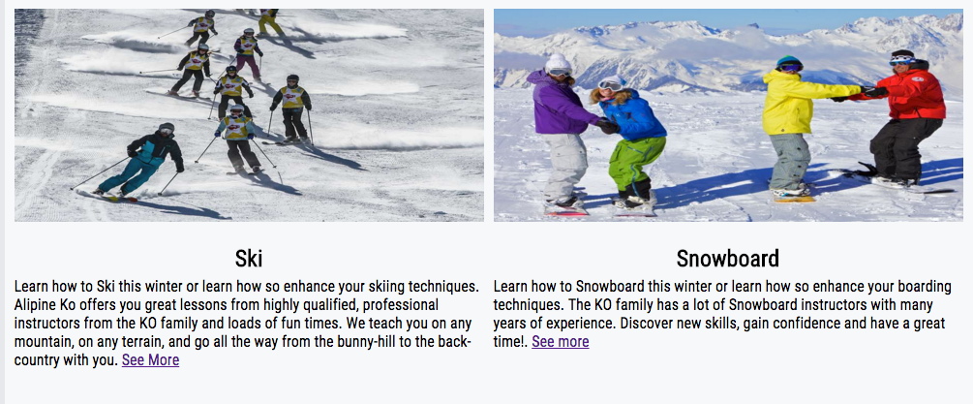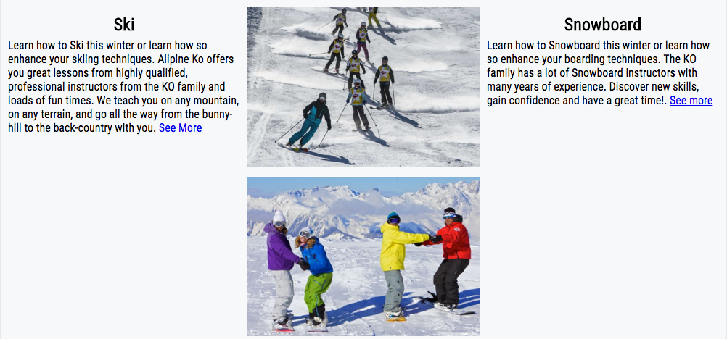

Tested visuals to see what would look more appealing to the user. The first one consists of only 2 divs the second one has 3 divs 1 is set for only the images.

**Skiing Lesson Page**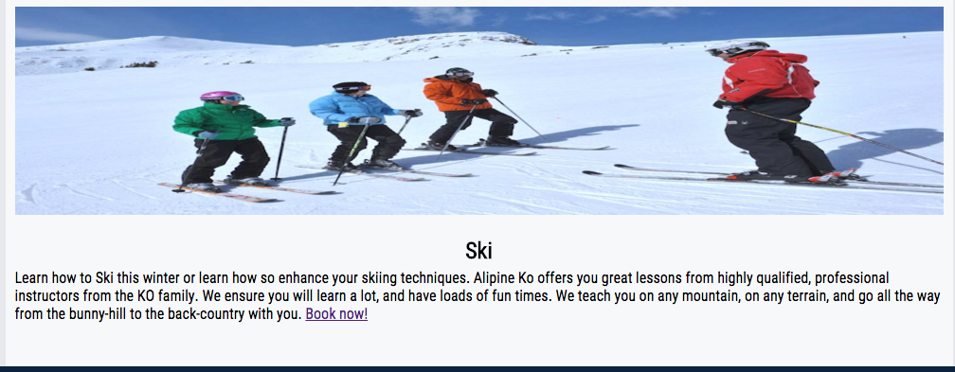

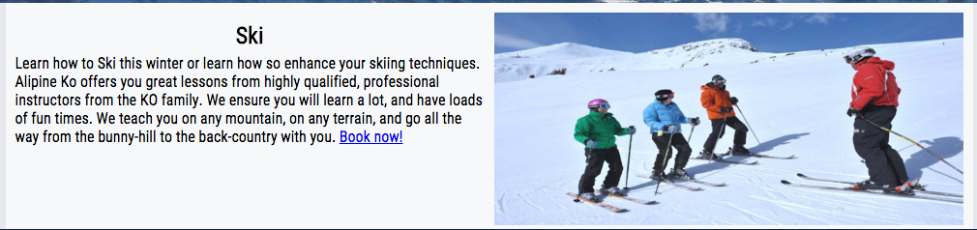

Tested making the image its own dev so it would sit next to the text compared to the image being above the text.

**Snowboard Lessons Page**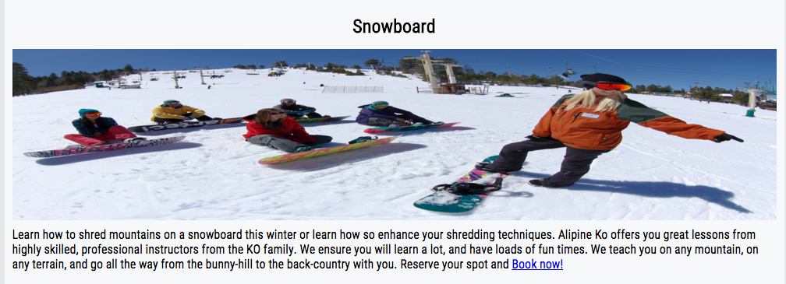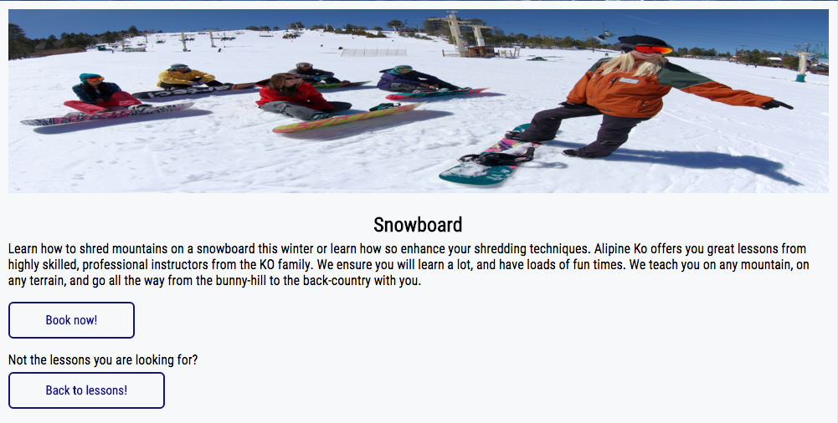

Added buttons to the book now! page and back to lesson! to make it easier for the visiter.

**Rental Booking Page**

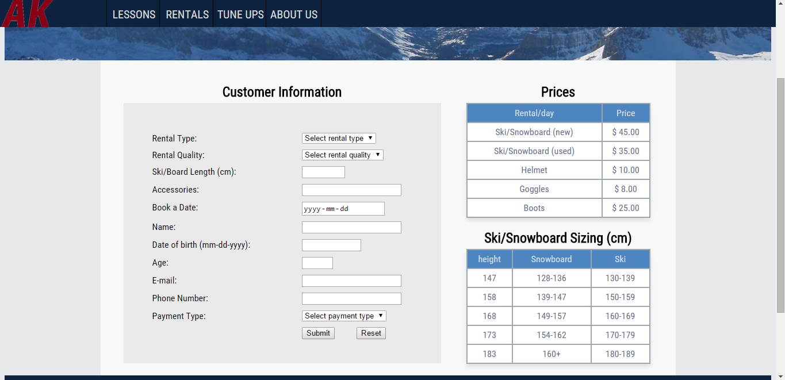

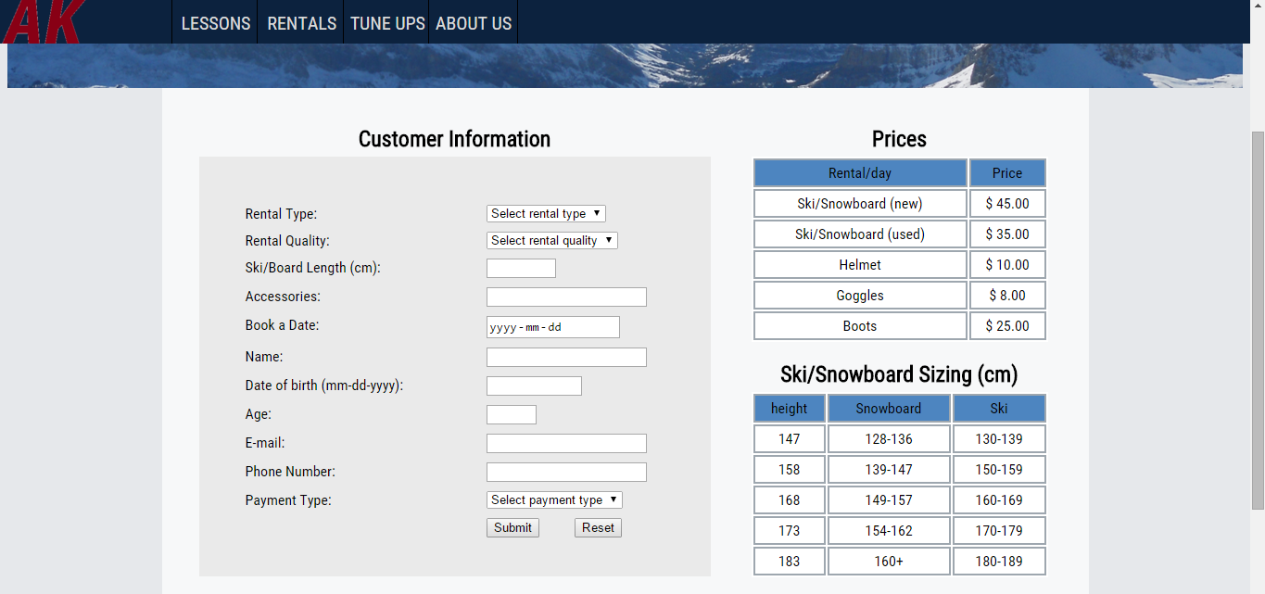

Tested two different tables to see which was more visually appealing. One table had a collapsed border, box shadow and grey font.

**Lesson Booking Page**

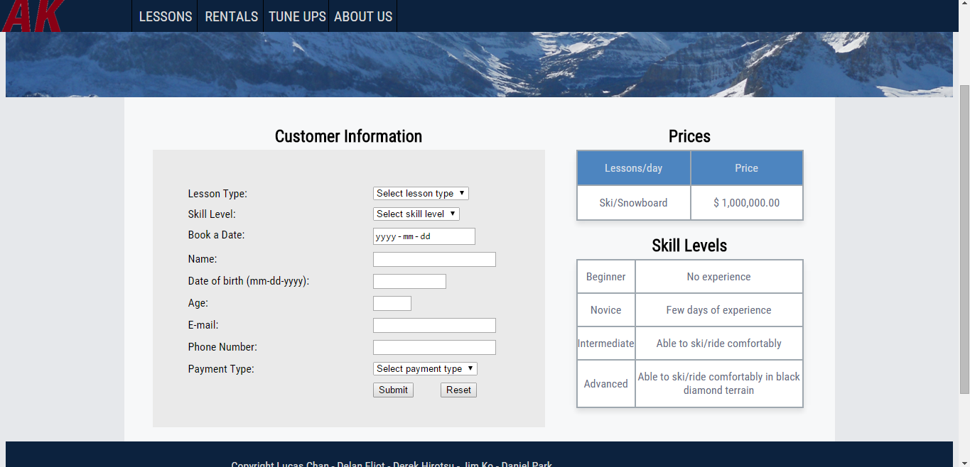

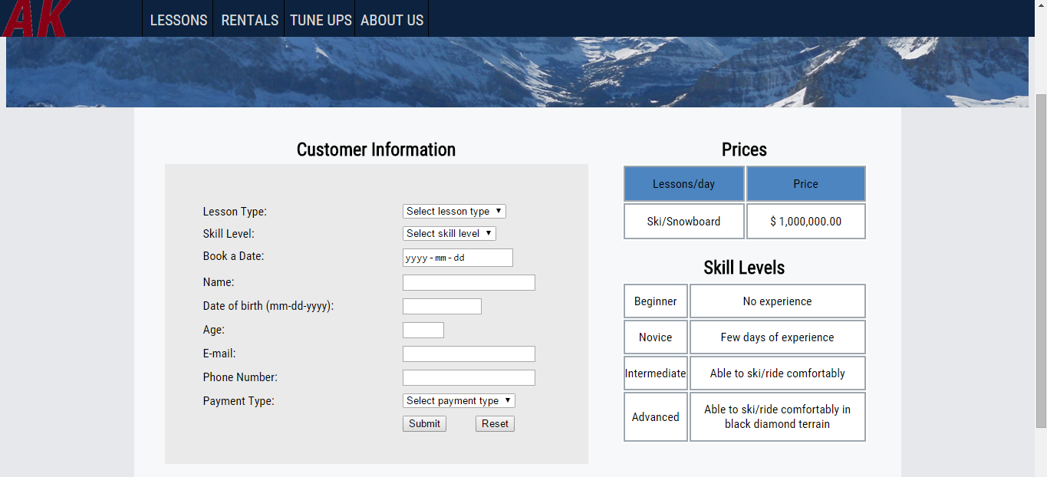

Tested two different tables to see which was more visually appealing. One table had a collapsed border, box shadow and grey font.

**Tune Ups Page**

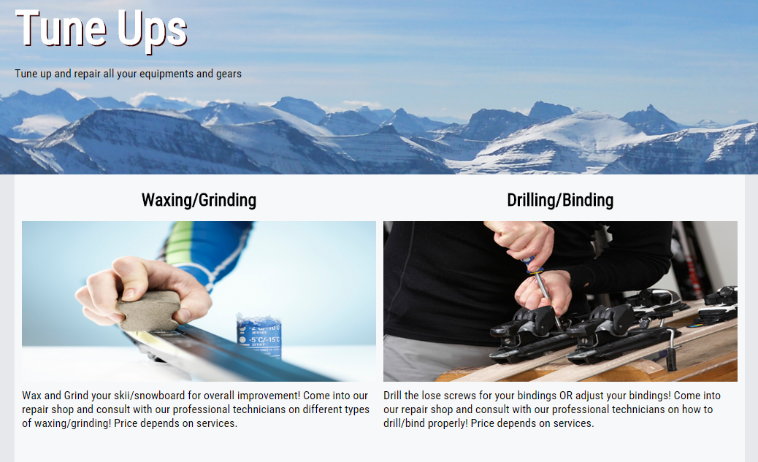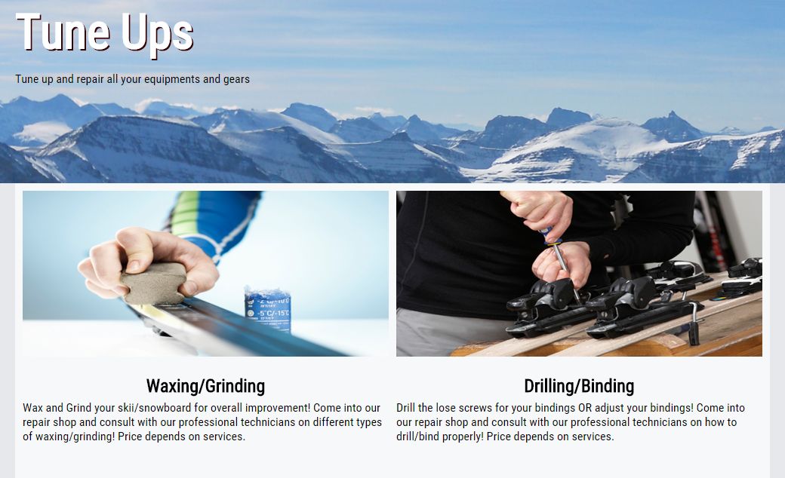

Tested for visual clarity in regards to having the headings above the images and separated from the body paragraphs versus having both the headings and the body together under the images.

**About Us Page**

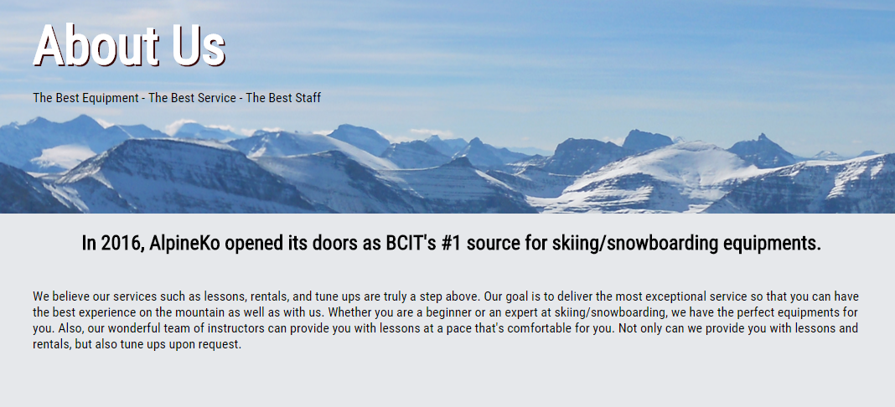

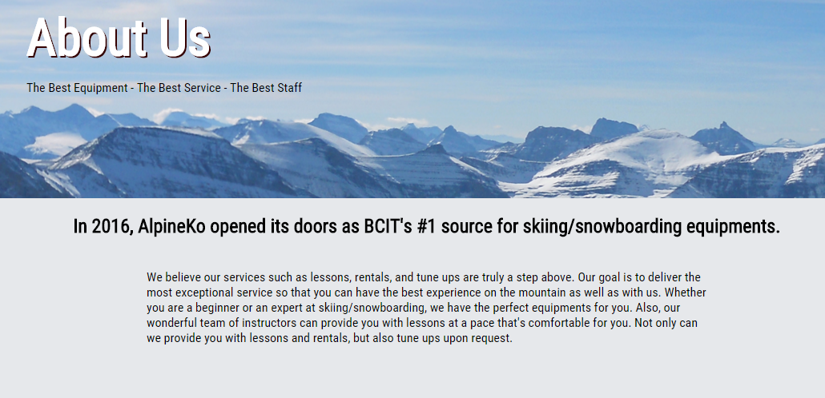

Changed the content width from 1000px to 700px to reduce the reader’s horizontal eye movements.

**Contact Us Page**

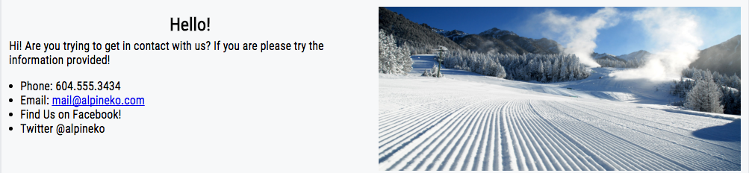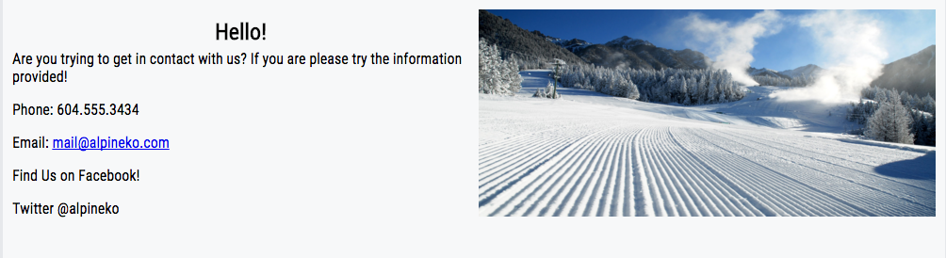

Tested the contact information to see if it would look better in a list or its own.

Lucas Chan

Delan Elliot

Derek Hirotsu

Jim Ko

Daniel Park

COMP 1536 Milestone 2

Home Page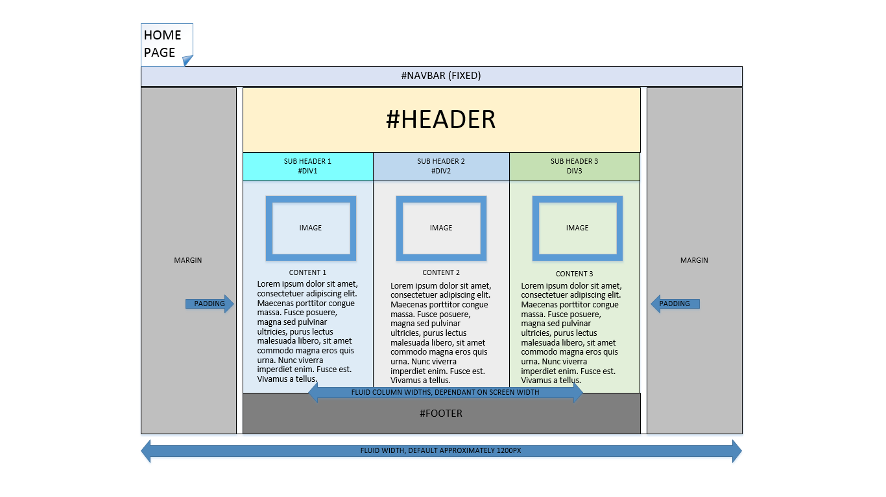

Our main goal for our website is to make it simple. We followed a three column content design with a fixed header to keep content well-delineated and self-contained. Our logo is designated as a home button on every page, and it will also be possible to access each of the other pages through drop-down navigation menus. We are going to have a maximum content width of 1200px, in a horizontal flex-box design that shrinks down until it flows to a vertical flex-box, single column.

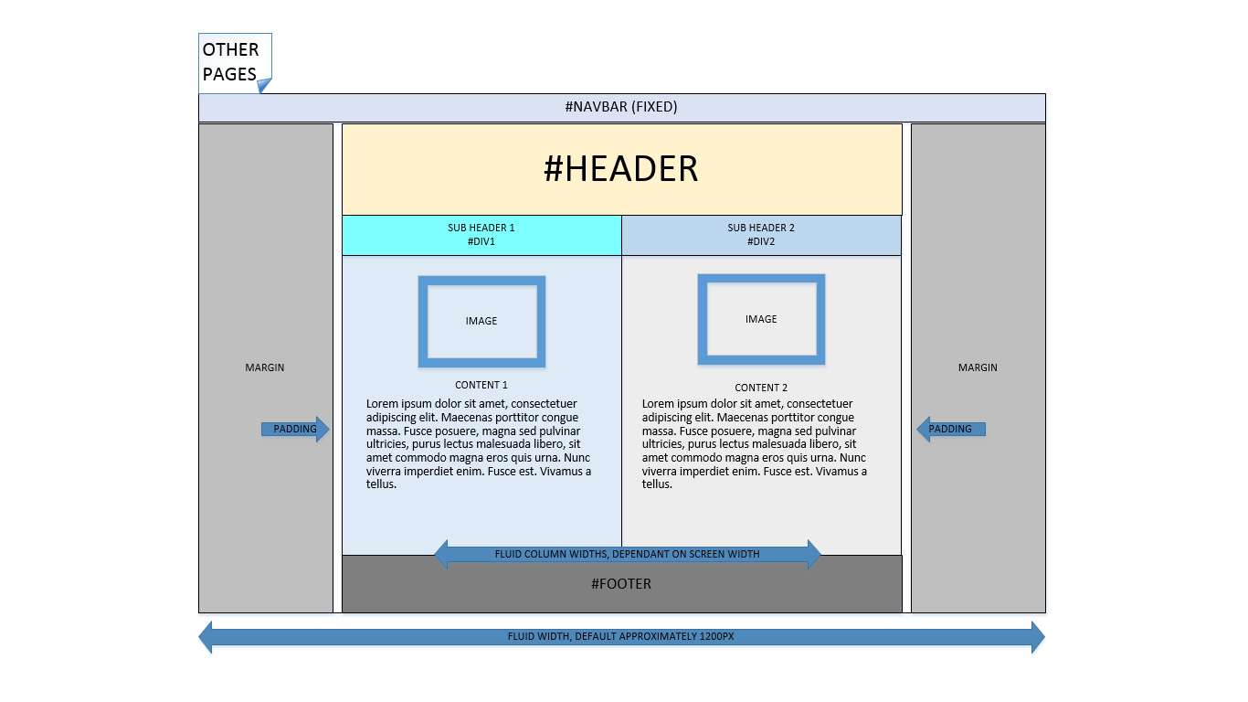Other Pages

This is one of our secondary pages. We kept it similar to our home page to make the visitors feel familiar to the site. We changed things up slightly with a 2 column design instead of the 3 column. We stuck with the same margins but plan to have a slightly small header on top. This is the general layout for subpages, with a smaller header to differentiate it from the homepage. We will retain the same design elements but put more emphasis on the textual content on these subpages.

Print Page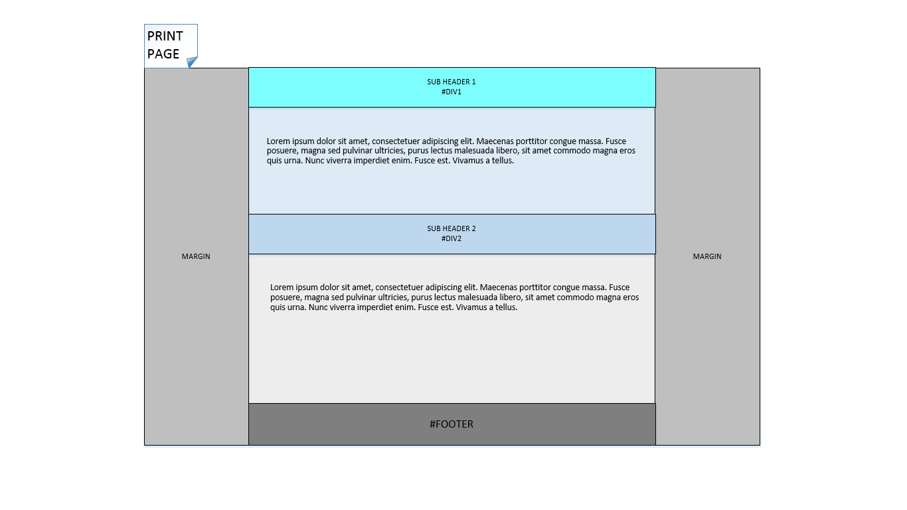

On the print page, we eliminated the graphics and simply placed the content with its headers on the page. The print stylesheet will designate all printable content and get rid of the header, navigation, etc.

Rental Booking Page

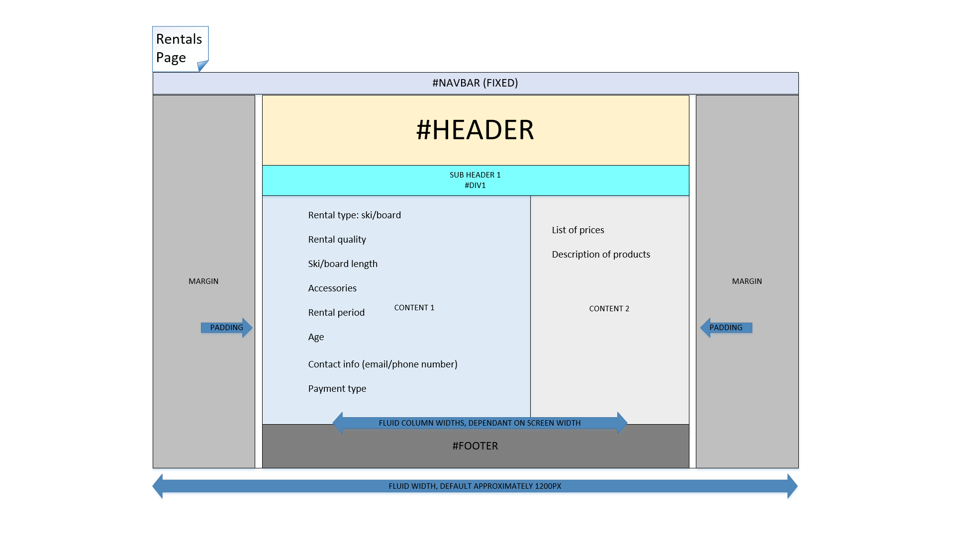

This is our rental booking page. It is a similar design to our 2 column design, but with a larger left column for the form section, and sidebar with prices and product information. Navigation and secondary header remains the same on this page. This page will also be 1200px max width and fluid to account for smaller screened devices.

Lesson Booking Page

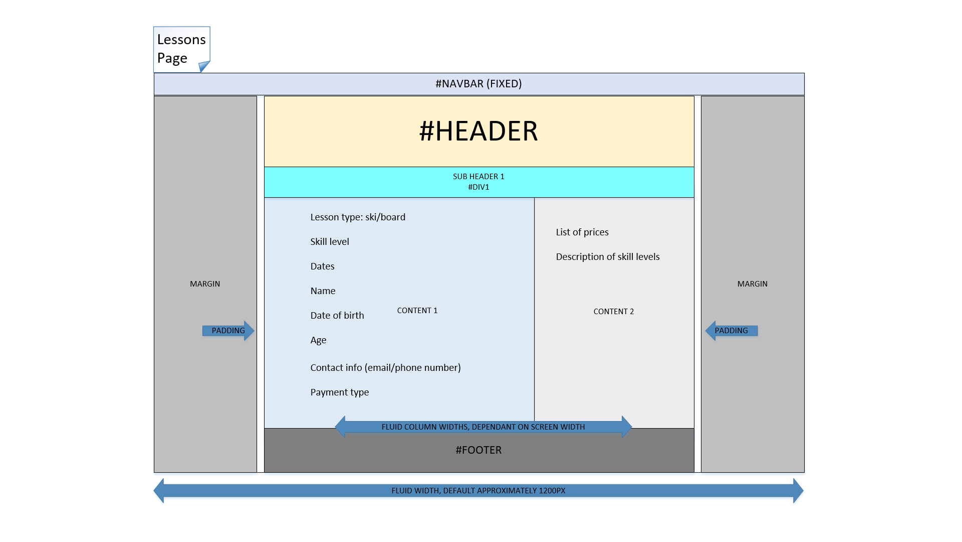

This is our lesson booking page, it has almost identical elements to our rental booking page. The forms will be different but the behavior of the site will be similar.

Site Map

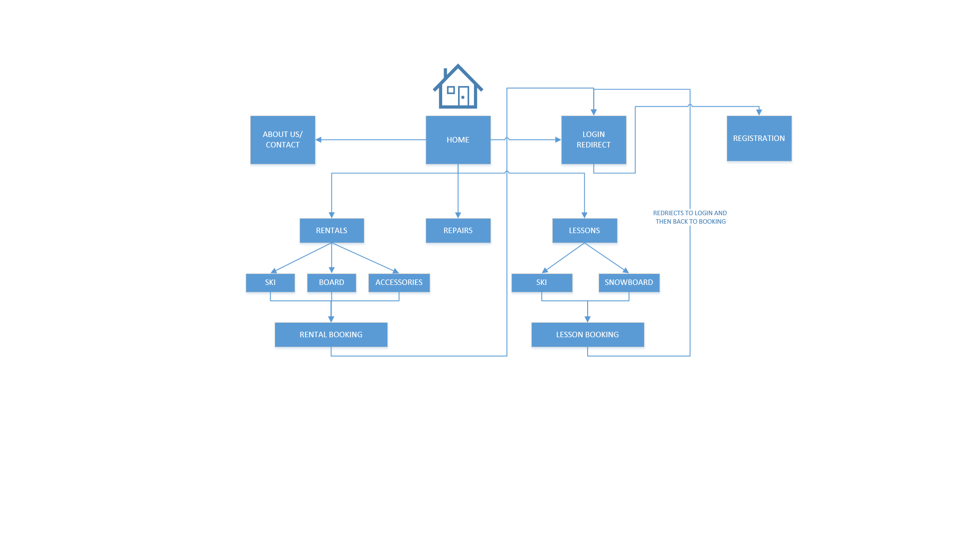

Site Map of where the buttons navigate around our site. In order to book lessons or rentals on our site, we will require the user to have an account. The login redirect will get the login or registration, and then redirect the user back to the page they wanted.

Color Pallet



We decided to go for something simple in color scheme. The blue reflects winter and the more neutral colour tone is easy on the viewer but looks sleek and professional.

AlpineKo Ski and Board

Lucas Chan

Delan Elliot

Derek Hirotsu

Jim Ko

Daniel Park

COMP 1536 Milestone 1

**Project Proposal**

We propose to build a website for a theoretical ski/board shop called *AlpineKo Ski and Board* located here in Vancouver.

**Purpose**

Our business offers equipment tune up and repair, gear rentals, and ski/ride lessons. The purpose of the site would be to provide current and potential customers with information and a portal for booking our services.

**Objective**

We aim to create new customers as well as maintain current customers through a user friendly site design with intuitive navigation. Our site has to primarily accomplish three things: list information about our services in a visually appealing manner, direct the user to the appropriate information intuitively, and interact with the user to book lessons and rentals.

**Target Audience**

Our target audience is current and prospective skiers and riders. We also want to make the site easy to use for parents of young potential skiers/riders. The main age demographics are 18-35, both male and female, and to parents of skiing and riding students.

**Type of Content**

i) Text content: Our text content will include information on services provided including price details and product descriptions, contact details, and hours of operation.

ii) Graphics content: A logo, banner, and page navigation graphics with a unified style and colour scheme.

iii) Media content: Photos of rental products, photos of lessons instructors, and flavour photos potentially for page background

**Success Factors**

Some of the success factors for our site will be: ease of use and navigation for the user (If a user wants a specific service they are easily and quickly able to find it), ability to retain customers and upsell services, visual appeal, and effectively handle service scheduling in terms of server side processing.

**Two Similar Sites**

i) *North Shore Ski and Board* (<http://northshoreskiandboard.com/nsstore/>): Cluttered navigation which we would try to avoid, tons of information being thrown at the user all on the home page, which can sometimes be easy to miss. We hope to avoid some of these problems by reducing the amount of information on the homepage and distributing it through streamlined navigation.

ii) *Crystal Glide Ski Board Service* (<http://www.crystalglide.ca/>): Messy layout that is visually unappealing, and the background and font clash together. The similar colour scale makes it hard to read the text, and reading the text is very unwelcoming. We will not be running into this problem since we are using colors that will stand out and be clear. The layout of the site is also very narrow, causing most of the content to be compressed together in the middle of the site, as well as creating a very cramped feeling layout. We are going to try to plan our website to feel spacious so it feels more inviting and is more inviting to our users.

**Functional Requirements**

Our user submitted content page will be a booking page for a lesson service which our site will offer. The user will be prompted to create an account and that account will be used to track booking times, types, and locations of lessons. Every page will have a “My Account” tab with account options and Login/Logout options. The booking page will take input from the user (desired times) and return with lesson time suggestions based on a given availability which the administrator can set. The user will also have other criteria such as “instructor” or “location”. We will also create a photo glossary of rental products and packages.

**Workplan**

We plan to meet in person to flesh out expectations and major decisions. During these in person meeting, we will divide work between the members with the objective of having each of the project milestones completed well in advance of the deadline. We will generally be meeting Monday-Friday before, after or between classes as each of our work schedules are different. We aim to be proactive about deadlines and finish each of the milestones in advance of their due-dates. As we will be learning the prerequisite skills for each deadline throughout the term, our project will allow us to practice the skills we are learning in labs. The work will be divided equally with emphasis on playing to each of our skills. Once we figure out who is good at each of the required tasks, we will decide specifically who will be responsible for which part of the site. We, of course, would like to play to our strengths, but we will also try to ensure no one feels that they have to contribute an undue amount of work. We will be setting up a GitHub repository to keep track of all changes, and potentially using WebMatrix as well.